**Getting Started Exercises with Typescript and Node.js**

1. **Install Node.js, Typescript and VS Code on your computer.**

**Node .js:-**

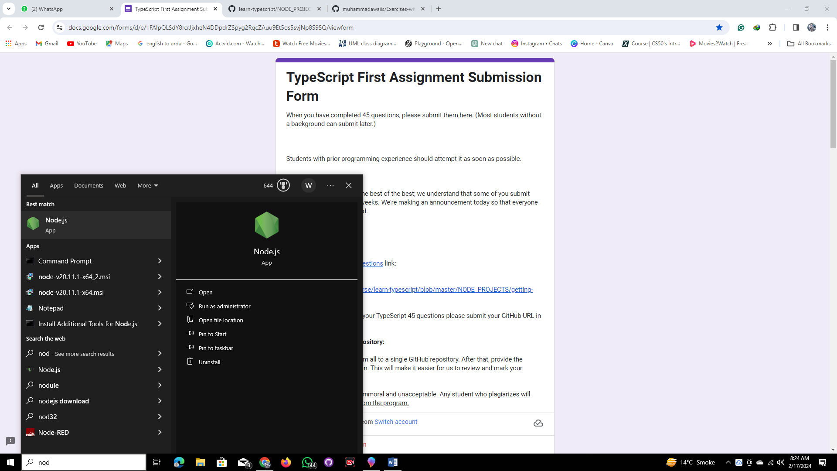

**2nd step:-**

Node –version:-

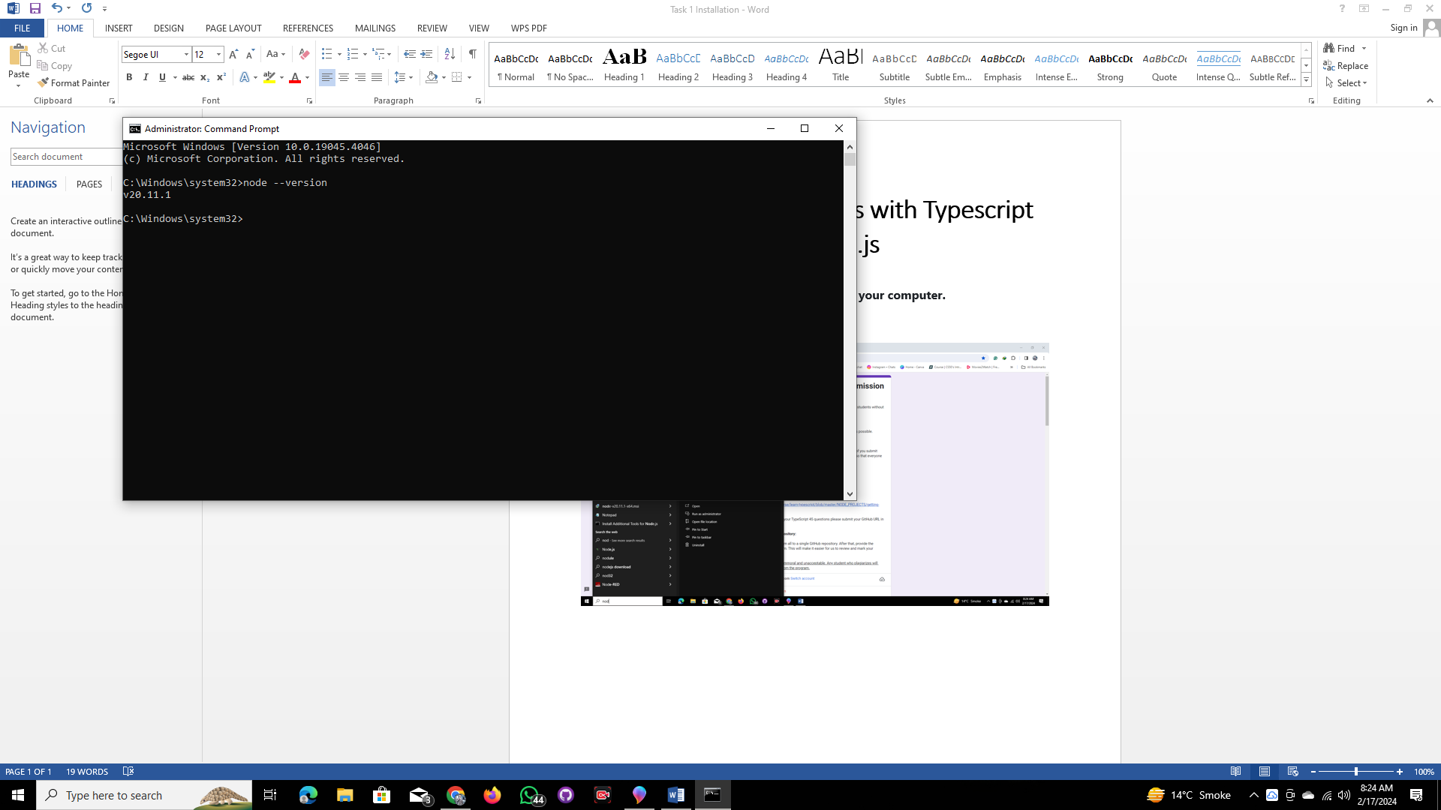

Visual studio Code:-

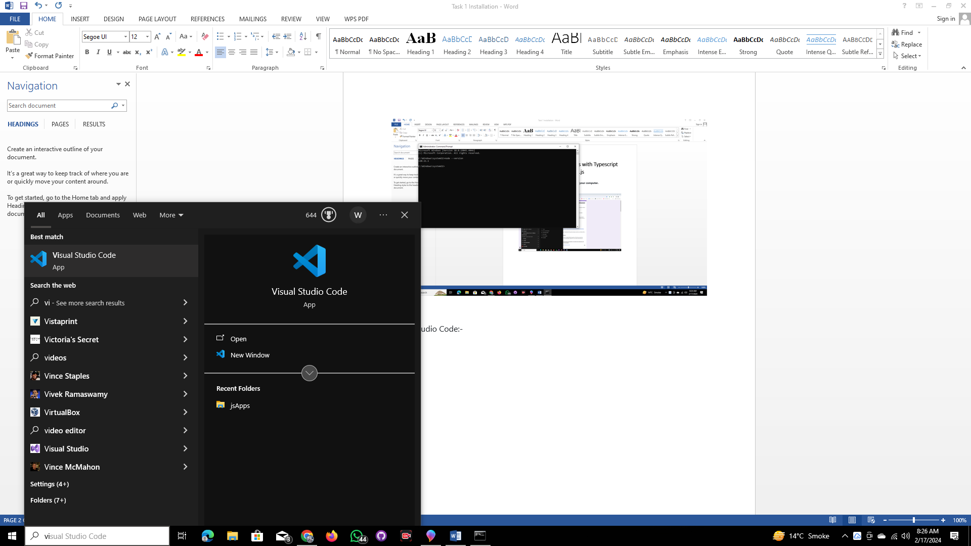

Hello World Program:-

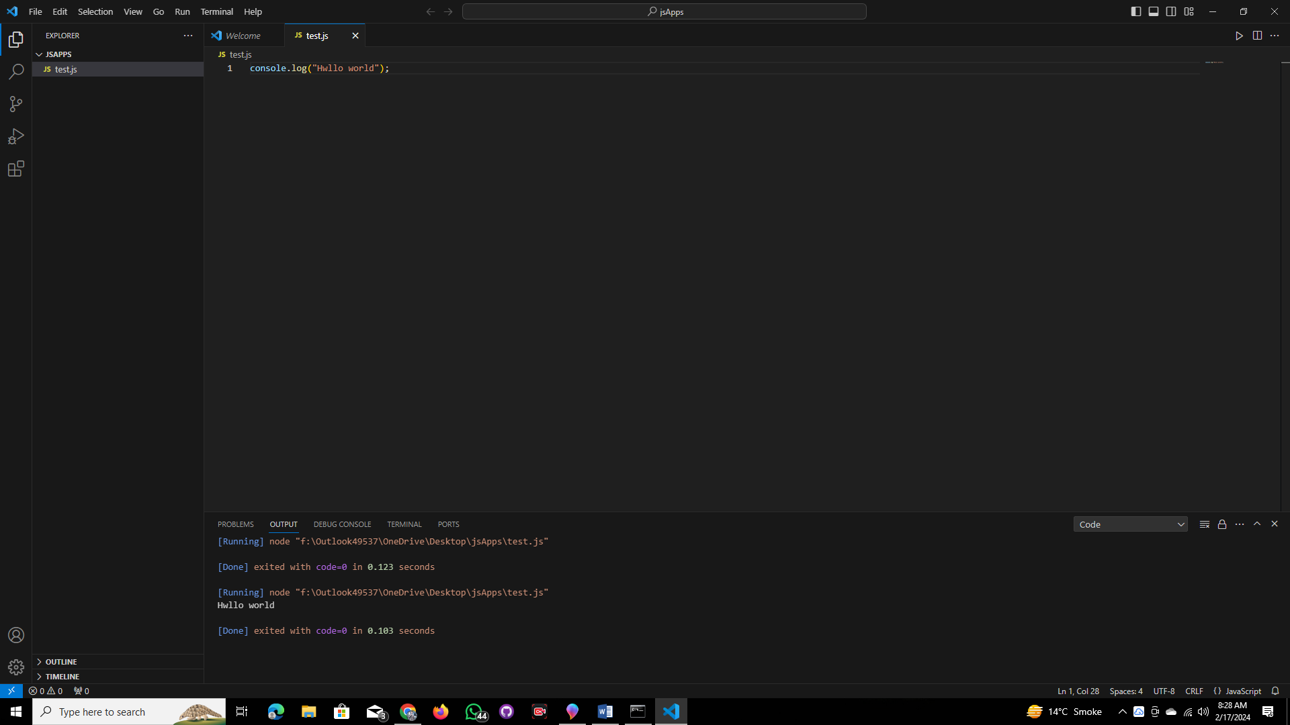

Typescript installation:-

npm install typescript --save-dev

npx tsc

**End!**